Client Complaint form
1: Tell us about you
First name
Last name
Address
Home Phone:
Mobile Phone:
Email:
2: Tell us about your complaint: Who are you unhappy with?

What made you unhappy?
Tell us what happened.

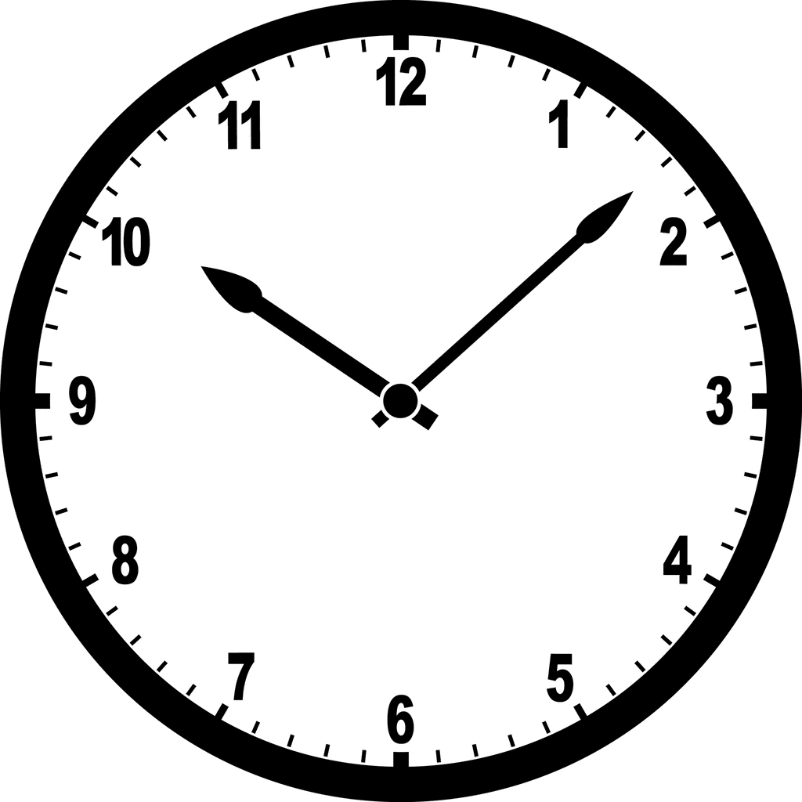
When did it happen?

What would make you happy?
Tell us what you would like to happen.

We might need to talk to you to help fix your problem. Are you okay with this?
Circle your answer (or delete the
other answer).
No

Yes

Follow Up:
Manager - Outcome:

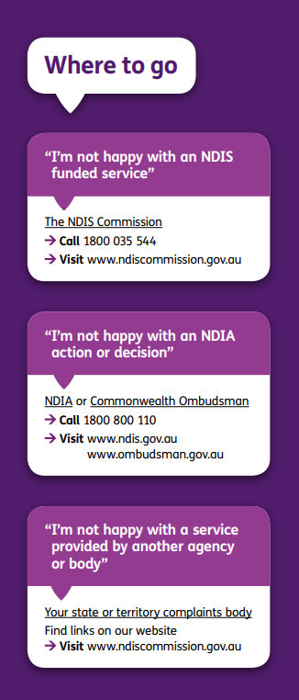
Clients response to the resolution:

Client suggestions for improving the complaints process:

